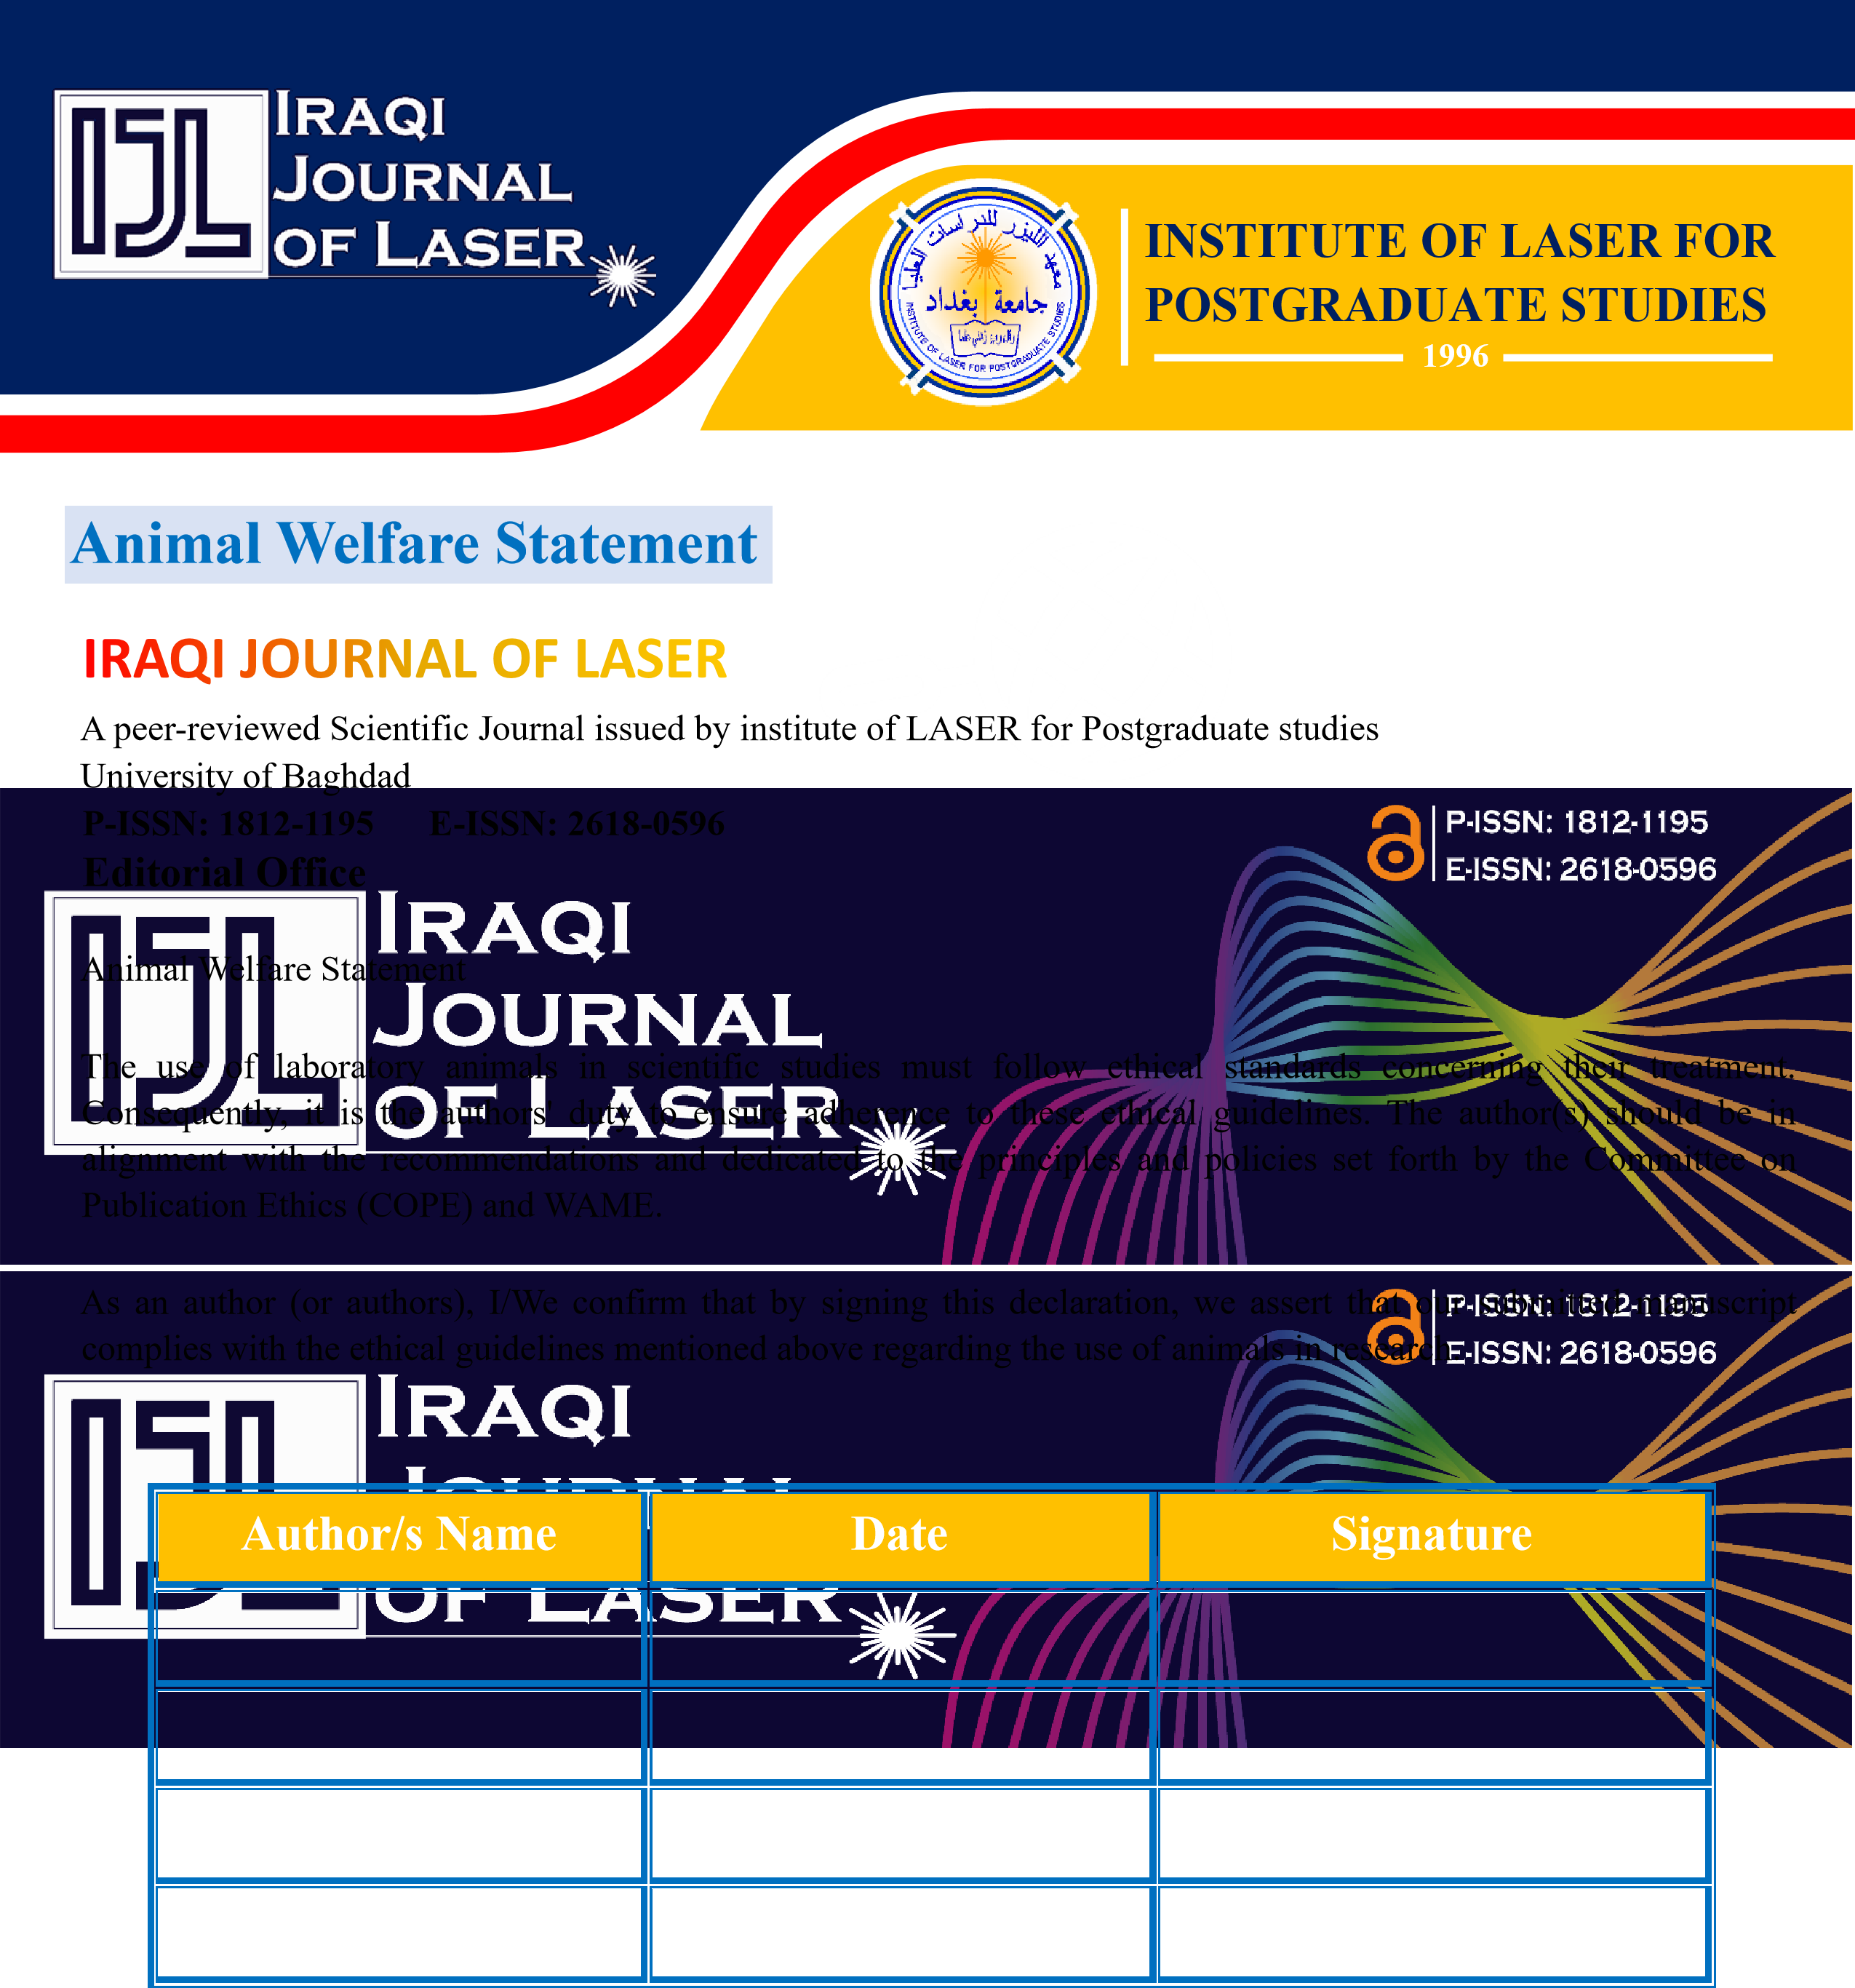
Cover letter sample to the IJL
Name of corresponding author:-
Full Address -----------------------------------------.
phone number ------------------------------------.
Date: - dd/mm./yy
Dear Sir,
I wish to submit a new manuscript entitled “-------------” for consideration by Iraqi journal of laser.
I confirm that this work is “original Articles or articles or Review, invited reviews, special Survey” , has not been published previously, elsewhere nor is it currently under consideration for publication, and that its publication is approved by all authors, and that, if accepted, it will not be published elsewhere, including electronically, in the same form, in English or in any other language
full address, email, and phone number of all other authors: -
-----------------------------------------------------------------------------------------------------------------------------------------
----------------------------------------------------------------------------------------------------------------------------------------------
------------------------------------------------------------------------------------------------------------------------------------------------
Thank you for your consideration of this manuscript.

Sincerely,
Corresponding Author

Greetings from IJL
To further acknowledge your manuscript for review, we ask you to suggest at least four potential reviewers, with great thanks for more, who are explicitly interested in the topic. The proposed reviewers should be working out of the author's current institution and/or from indexed overseas universities or institutions.
“Eligible reviewers should have an H index of 5 or above and have a total of no less than 50 citations in their SCOPUS profile”
Please remember to provide emails, ORCID, and SCOPUS links for all suggested reviewers with your letter.
At this time, you may need to be aware of our policy:
Any misleading or inaccurate information might result in the paper being outright rejected.

List of suggested reviewers:

 | Name | E mail | ORCID | SCOPUS
1
 | AFFILIATION
2
 | AFFILIATION
3
 | AFFILIATION
4
 | AFFILIATION
5
 | AFFILIATION



