
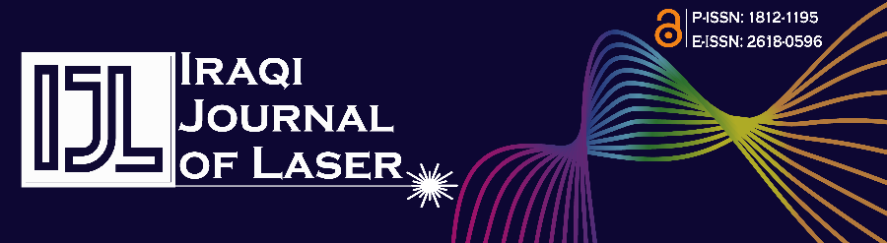
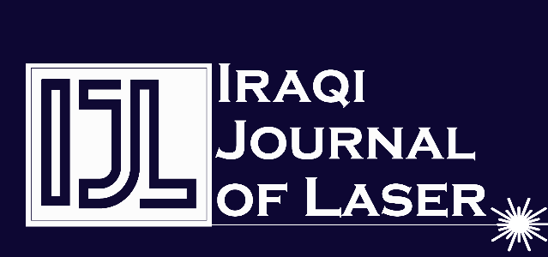
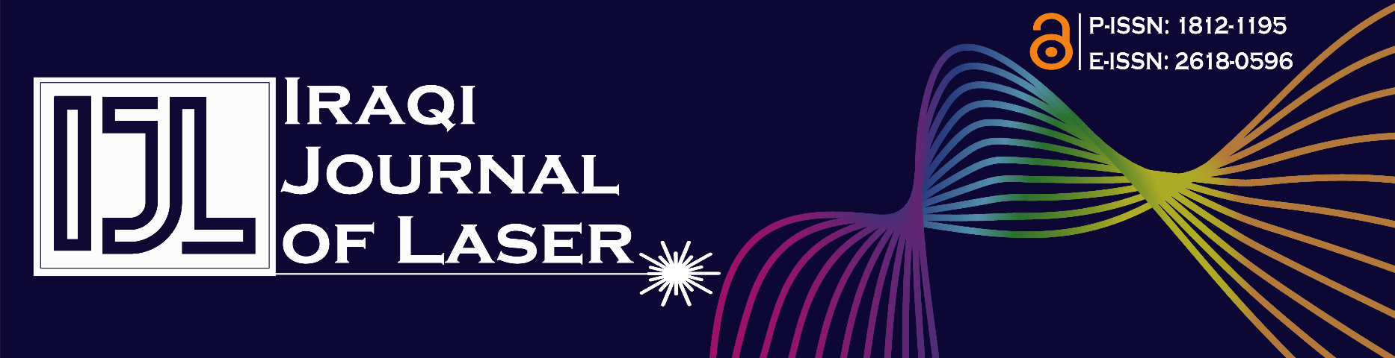
Animal Welfare Statement

IRAQI JOURNAL OF LASER
A peer-reviewed Scientific Journal issued by institute of LASER for Postgraduate studies
University of Baghdad
P-ISSN: 1812-1195 E-ISSN: 2618-0596
Editorial Office

Animal Welfare Statement
The use of laboratory animals in scientific studies must follow ethical standards concerning their treatment. Consequently, it is the authors' duty to ensure adherence to these ethical guidelines. The author(s) should be in alignment with the recommendations and dedicated to the principles and policies set forth by the Committee on Publication Ethics (COPE) and WAME.
As an author (or authors), I/We confirm that by signing this declaration, we assert that our submitted manuscript complies with the ethical guidelines mentioned above regarding the use of animals in research.

Author/s Name | Date | Signature

ijl@ilps.uobaghdad.edu.iq
www.ijl.uobaghdad.edu.iq
1996
INSTITUTE OF LASER FOR POSTGRADUATE STUDIES

